**Fuel pump**

A fuel pump is an essential component of the [fuel system](https://www.newkidscar.com/fuel-system/) on a car. Fuel pumps use in carbureted and injected engines. By the depending to where fuel pump are using, they divided on the different types of fuel pumps.

**Purpose of Fuel Pump:**

The Fuel pump`s purpose is supply fuel from [fuel tank](https://www.newkidscar.com/fuel-system/fuel-tank-construction/) to the engine [cylinder](https://www.newkidscar.com/engine-construction/engine-cylinder-construction/). Fuel pump of modern injection systems must create the high pressure, so are often used Electrical fuel pumps.

There are three main types of fuel pumps that your vehicle may be equipped with. Each functions differently so it is important to understand the characteristics of one against another. For example, when shopping for a fuel pump, you will need to know if it pumps the gas into a carburetor or into the **fuel injection system**. Here’s more information on the different types and what they mean for you.

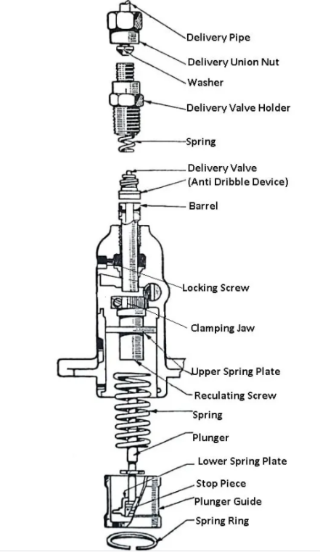

## ****Fuel pump****

## Construction and Working of a Fuel Pump: The plunger is driven by a cam and tappet mechanism at the bottom. The plunger reciprocates in the barrel. There are as many plungers as the number of cylinders in the engine. The plunger has a rectangular vertical groove. The delivery valve is lifted off its seat under the pressure of the fuel against the spring. The fuel from the delivery valve goes to the injector. When the plunger is at the bottom of its stroke, the supply port and spill are uncovered, the fuel from a low-pressure pump after filtration is forced into the barrel.

Now the plunger is pushed up by the cam movement and both the parts are closed. On further movements of the plunger, the fuel above it is compressed which lifts the delivery valve and the fuel through it goes to the injector.

The plunger rises up still further, and at a particular moment, the helical groove connects the spill port, through the rectangular groove to the fuel in the upper part of the plunger. Consequently, there is a sudden pressure drop due to which the delivery valve falls back on its seat under the spring force. The pressure in the delivery pipe also drops. Thus the discharged from the nozzle of the injector is cut off suddenly. The cycle is repeated again and again.

During each stroke of the plunger, the duration of the delivery is more or less according to as the spill port is made to communicate earlier or later, the high-pressure fuel in the upper part of the barrel. This depends upon the position of the helical groove which can be changed by rotating the plunger by the rack.

The rack is connected to the accelerator. It meshes with a geared quadrant. The motion of the rack rotates the gear quadrant which ultimately rotates the plunger. The driver simply operates the accelerator which controls the fuel supply to the engine cylinder.

**Types of Fuel Pumps:** The fuel pump is used in the fuel system to deliver fuel from the fuel tank to [the carburettor.](https://www.theengineerspost.com/types-of-carburetors/) Many types of fuel pumps are used in modern automobile vehicles.

1. **Low-pressure fuel pumps** – is mounted on the carbureted engines outside the fuel tank;
2. **High-pressure fuel pumps** – is mounted on diesel and injection engines.

The modern fuel injected engines often use **electric fuel pumps**, which are mounted inside the [**fuel tank**](https://www.newkidscar.com/fuel-system/fuel-tank-construction/).

A fuel pump draws petrol out of the fuel tank by a pipeline to the carburetor, so sometimes it names petrol pump. The mechanical pump has drive from an engine. And electric fuel pump is usually mounted near the tank or inside the tank.

The performance of fuel is tested by pressure, volume and vacuum. A pump must produce certain pressure on the outlet side as specified by the manufacturer. To test a pump for pressure, connect a pressure gauge between the pump and the carburettor and run the engine at a specified speed. The gauge will indicate the pressure created by the fuel pump.

For volume test, disconnect the fuel from the carburettor and run the engine at idling speed. Measure the volume of fuel coming out from the pump by collecting it in a separate container.

For vacuum test, connect a suitable vacuum gauge between the gauge tank and then run the engine at idling speed. The gauge indicates the vacuum generated inside the pump to suck the fuel from the fuel tank.

The vacuum must be retained for at least ten seconds after closing the engine. The fuel pump found connect in the above three tests should be used in the fuel system.

## ****How a mechanical fuel pump works:****

## 

## **C:\Users\ahmed\Desktop\Capture.PNG**

**Fuel pump diagram**

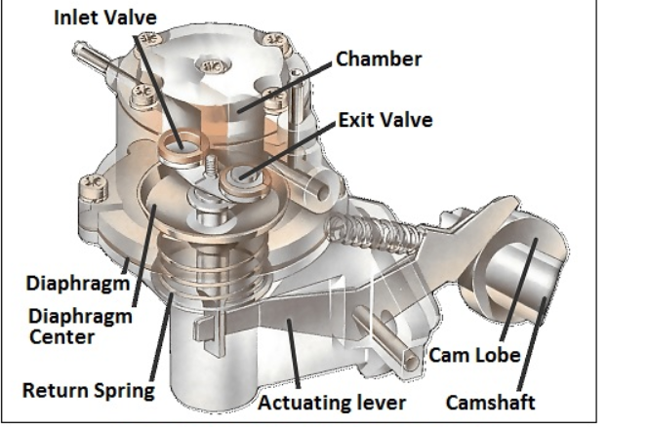

**Mechanical fuel pump**

**How Mechanical pump works:** Mechanical pump`s actuating lever moves up and down during the working. When need to fill the pump chamber lever pulls the diaphragm down.  The return spring moves the diaphragm up to deliver fuel to the carburetor device.

A mechanical fuel pump is driven by the camshaft , or by a special shaft driven by the crankshaft . As the shaft turns, a cam passes under a pivoted lever and forces it up at one end.

The other end of the lever, which is linked loosely to a rubber diaphragm forming the floor of a chamber in the pump, goes down and pulls the diaphragm with it.

When the lever pulls the diaphragm down, it creates suction that draws fuel along the fuel pipe into the pump through a one-way valve .

As the revolving cam turns further, so that it no longer presses on the lever, the lever is moved back by a return spring , relaxing its pull on the diaphragm.

The loosely linked lever does not push the diaphragm up, but there is a return spring that pushes against it.

The diaphragm can move up only by expelling petrol from the chamber. The petrol cannot go back through the first one-way valve, so it goes out through another one leading to the carburettor.

The carburettor admits petrol only as it needs it, through the needle valve in its float chamber (See [How variable-jet carburettors work](https://www.howacarworks.com/basics/how-variable-jet-carburettors-work) ). The first valve is one way, so the petrol cannot move back and moves to the carburetor through another valve.  The carburetor needle valve which mounted into the float chamber regulates admits the petrol as it needs.

In our time by the widespread adoption of electronic fuel injection are used electric fuel pumps. We will talk about electric fuel pumps in next paragraph.

In a mechanical pump the actuating lever moves up and down constantly, but pulls the diaphragm down only as needed to refill the pump chamber. The return spring pushes the diaphragm up to deliver petrol to the carburettor. While the carburettor is full and the needle valve is closed, no petrol leaves the pump. The diaphragm stays down, and the lever idles up and down.

When the carburettor accepts more petrol, the return spring pushes the diaphragm up and, by taking up the slack in the loose linkage, brings it back into contact with the lever, which again pulls it down to refill the pump chamber.

**Electric Fuel Pump:**

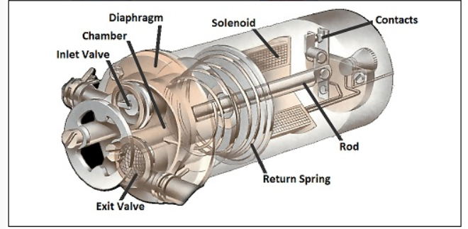

**How Electric Fuel Pump Works:**

An electric pump has a similar diaphragm-and-valve arrangement, but instead of the camshaft, a solenoid (an electromagnetic switch ) provides the pull on the diaphragm.

The solenoid attracts an iron rod that pulls the diaphragm down, drawing petrol into the chamber.

At the end of its travel the iron rod forces apart a set of contacts, breaking the current to the electromagnet and relaxing the pull on the diaphragm.

When the diaphragm return spring raises the diaphragm, it also pulls the rod away from the contacts; they then close so that the solenoid pulls the rod and diaphragm down again.

## Circulating petrol continuously:

Most mechanical and electrical systems pump fuel only when the carburettor needs it. An alternative system has a complete circuit of pipes, from the tank to the carburettor and back again. The pump sends petrol continuously round this circuit, from which the carburettor draws petrol as it needs it.